**How to setup an email account for Outlook 2013**

1. Open Outlook
2. Go to File
3. Click on Account Settings
4. Click on Account Setttings again
5. Under E-mail, click New

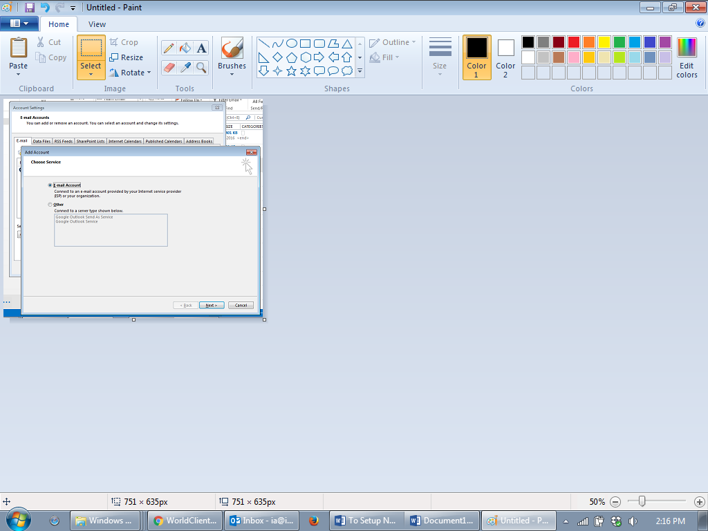

Click Next,

1. Click on Manual setup or additional server types, then click Next

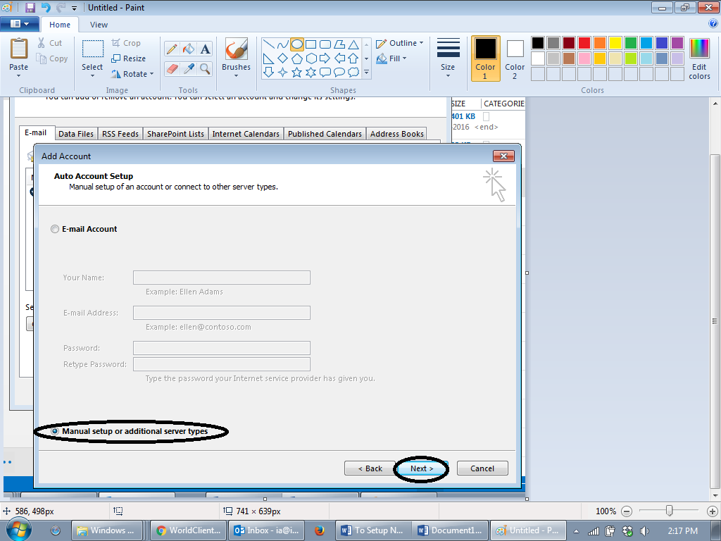

1. Click on POP or IMAP, then click Next

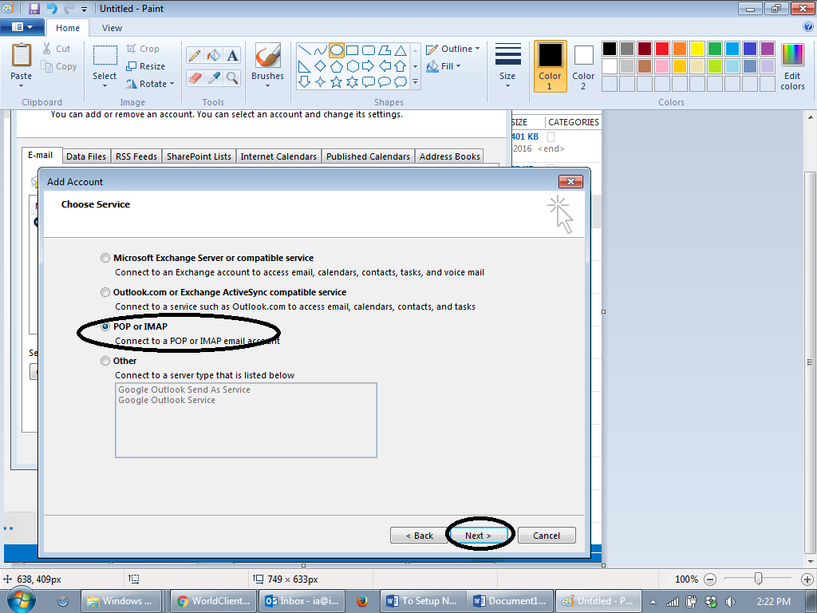

1. Type in your details for all the textboxes beside the black arrows as shown below (you must have existing email address), and then click Next

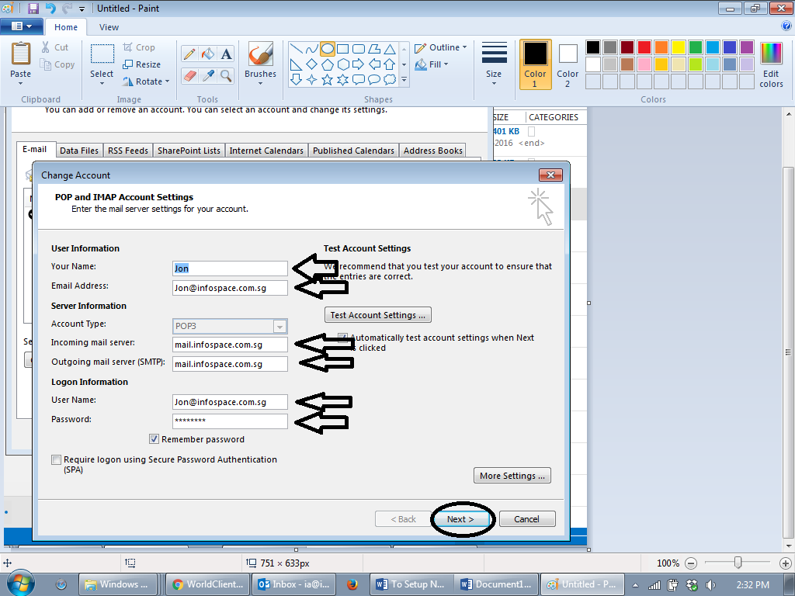

1. You should see this screen:

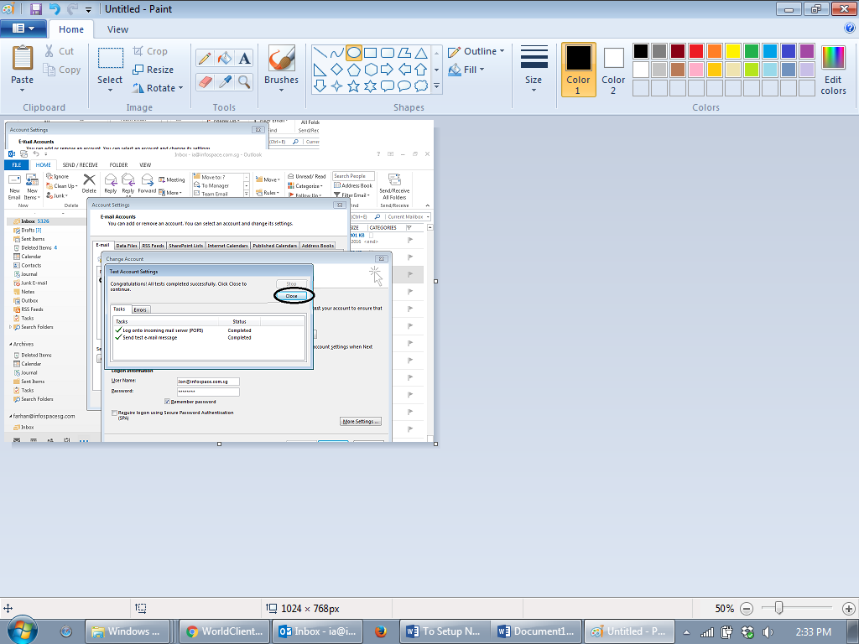

Click Close and you’re all done!